Grade Assist RTT – PHEV_FHEV – With Soft Menu - CGEA 1.3

Functional Description

The Grade Assist RTT functions differently when there is a physical button vs. having a soft button (i.e. soft menu in either cluster or center stack). At this time, only certain PHEV or FHEV vehicles offer a soft button for Grade Assist. Thus, this STSS is used along with “Grade Assist Control Function - PHEV_FHEV - CGEA1.3_v1.0.doc.”

The purpose of the Grade Assist RTT (when in the green ON state) is to inform the driver that the automatic transmission is in the Grade Assist mode. Grade Assist attempts to maintain the speed of a vehicle on a significant (greater than 3%) downhill grade. There are no message center warnings linked to this RTT.

Some xHEV clusters have a grade assist menu in the cluster (see Grade Assist Control Function - PHEV_FHEV - CGEA1.3 STSS). When enabled via a menu (instead of a physical button), the grade assist now has a standby state. The icon is shown in grey when in standby, and will change to green when grade assist active (on). As an FYI, on other vehicle lines that have a physical button there is only an amber Grade Assist On indication.

At this time there are no plans to support a physical button on Gen 4 Hybrids. Grade Assist as a feature is mandated by TRUSTMARK RQT-070100-006637. On the vehicles, Grade Assist will be available on all future Power-split PHEV/FHEV vehicles which do NOT meet the following criteria: SST, or Sport Mode with paddle shifters, or Trailer tow.

The Grade Assist On RTT correlates the GrdAsstActv_B_Stat signal and the Operational_Mode to illuminate or extinguish the Grade Assist RTT. The color of the RTT is determined by the menu selection, which generates the input Grade_Assist_Standby_Rq_Flag from the Grade Assist Control Function - PHEV_FHEV - CGEA1.3.

This section describes the RTT function and sets a flag that is used by the Message Center display (See Message Center Section for details of Message Display Algorithm).

Interfaces

Interface Context Diagram (I/O Block Diagram)
Figure 1. Grade Assist RTT Indication
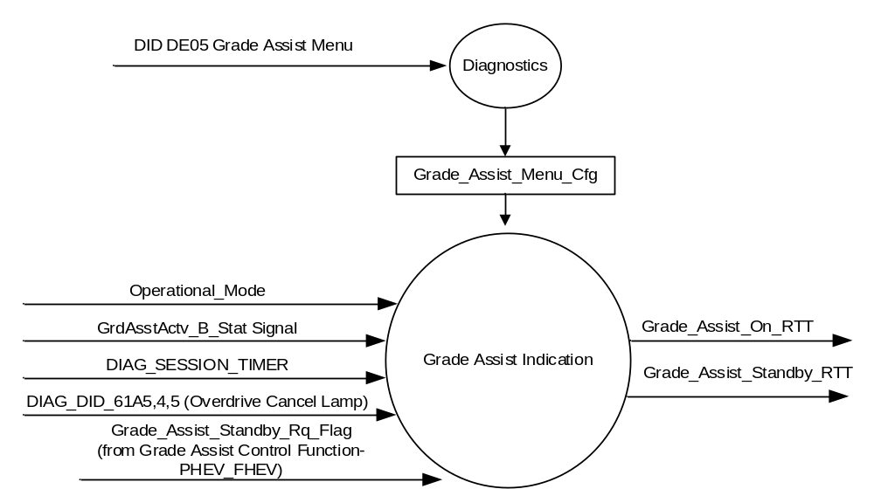

Inputs
      - INTERNAL:
            - DIAG_SESSION_TIMER
            - Operational_Mode
            - DIAG_DID_61A5,4,5 (Overdrive Cancel Lamp)
            - Grade_Assist_Standby_Rq_Flag (Request to show the RTT in Grey (Standby) from Grade Assist Control Function – FHEV_PHEV STSS)
            - Grade_Assist_Menu_Cfg (Defined in Grade Assist Control Function – FHEV_PHEV STSS)
      - MUX signal

- GrdAsstActv_B_Stat Signal
Signal Name | Size  (bits) | Detail | Units | Res. | Offset | State Encoded | Min. | Max.
GrdAsstActv_B_Stat | 1 |  | SED | 1 | 0 |  | 0 (0x0) | 1 (0x1)
 |  | Off |  |  |  | 0x0
 |  | On |  |  |  | 0x1

Outputs
- Grade_Assist_On_RTT, which is used to control the state of the Reconfigurable Telltale in the On state
- Grade_Assist_Standby_RTT, which is used to control the state of the Reconfigurable Telltale in the Standby state

Function/Performance

Operational Modes

Mode | Differentiating Vehicle Conditions
Sleep Mode | Grade_Assist_x_RTT Inactive
Limited Mode | Grade_Assist_x_RTT Inactive
Normal Mode | Grade_Assist_x_RTT Active/Inactive
Crank Mode | Grade_Assist_x_RTT Active/Inactive

The above table references the setting of the RTT flag as per this section. However, the actual RTT display operational modes are displayed in the Message Center section of this SPSS.

Voltage Levels

Refer to the Cluster Features table located in the Operational Modes and Voltage Range Strategies Section in this SPSS

Human-Machine Interface

Visual

Indicator Graphics / Display Format

Passenger Car (sedan) SUV

Pixel Definition

For actual symbol definition see pixel definition section in the message center section.
The pixel representation is based upon the symbol definition database # TBD of the 03-0685 ARL requirement.

Indicator Color Coordinates

Green - Reference SDS IL-0017/IS-0379
Grey - Reference SDS IL-0017/IS-0379

Indicator Characteristics

Pixel Display in Message Center Display – GRADE ASSIST RTT for Car (#27) & GRADE ASSIST RTT for SUV (#28). Both are referenced as “tbd.92” in the Global Message List.

Audio

None

Switch Control Logic

Not Applicable

System Accuracy

The state of the Grade_Assist_On_RTT and Grade_Assist_Standby_RTT shall change within 100msec of a state change as indicated in the state matrix reference 1.3.5.1 Subsystem Algorithm Flowchart/ State Diagram

Operation: Performance and Functional

Subsystem Algorithm Flowchart / State Diagram

- State Matrix for Grade_Assist_On_RTT and Grade_Assist_Standby_RTT Flags

Operational_Mode | DIAG_SESSION_TIMER | DIAG_DID_61A5,4,5 (Overdrive Cancel Lamp) | Grade_Assist_Standby_Rq_Flag | GrdAsstActv_B_  Stat Signal | Grade_Assist_Standby_RTT  (Grey) | Grade_Assist_On_RTT  (Green)
Normal or Crank | Not Active | X | X | 0x1 (On) | Inactive | Active
Normal or Crank | Not Active | X | X | Missing as per 1.4.1 | Inactive | Inactive
Normal or Crank | Not Active | X | Active | 0x0 (Off) | Active | Inactive
Normal | Active | Not Received | X | 0x1 (On) | Inactive | Active
Normal | Active | Not Received | X | Missing as per 1.4.1 | Inactive | Inactive
Normal | Active | Not Received | Active | 0x0 (Off) | Active | Inactive
Normal | Active | ON (0x1) | X | X | Inactive | Active
All Other Cases |  |  |  |  | Inactive | Inactive

X = Don’t Care
Not Received = The state when a DIAG_SESSION_TIMER is active and the DID has not been received.

Operation Description (supports algorithm flowchart /state diagram)

- Grade_Assist_RTT is a non-toggle small RTT (or, optionally a dedicated RTT). It does not get displayed as a Large RTT and therefore is not an RTTr and does not appear in System Check.
- The actual RTT display operational modes are displayed in the Message Center Section of this SPSS.

Function Safety Classification (EMC)

Class B

Memory Storage

Parameter Name | Description | Value at  Battery Connect | Value at  Module Wake-up
Grade_Assist_On_RTT | Used to control the state of the On RTT. This RTT is colored green. | 0x0 (Not Active) | 0x0 (Not Active)
Grade_Assist_Standby_RTT | Used to control the state of the Standby RTT. This RTT is colored grey. | 0x0 (Not Active) | 0x0 (Not Active)
Grade_Assist_Standby_Rq_Flag | Request from Grade Assist Control Function- PHEV_FHEV STSS to illuminate the grey Standby Grade Assist RTT. | 0x0 (Not Active) | Do Not Init
GrdAsstActv_B_Stat signal | CAN signal sent from the HPCM | 0x0 (Normal) | 0x0 (Normal)
Grade_Assist_Menu_Cfg | Allows the cluster to display the Grade Assist Settings menus and also the Grade Assist RTT. Defined in DID DE05  0x0 = Disabled, 0x1= Enabled | Use Stored Value | Use Stored Value
DIAG_DID_61A5,4,5 (Overdrive Cancel Lamp) | Warning Lamp Status 2, byte 4, bit 5 (Overdrive Cancel Lamp). This will only illuminate the Gade_Assist_On_RTT (green) | 0x0 (0) | 0x0 (0)
Operational_Mode | 4 state indicator for cluster operational mode | Limited | Limited or Normal or Crank

Parameter Name | Description | Value at Battery Connect | Value at Module Wake-up
DIAG_SESSION_TIMER | Timer used to time-out a diagnostic session | Not Active | Not Active

Prove Out

No

Reconfigurable Telltale

Yes – Non-toggle Small RTT. Optionally a dedicated RTT.

Message Center Msg

None.

Error Handling

Missing Message Strategy
The signal will be declared missing as per the Diagnostics Section of this SPSS.

DTC states and history will be determined as per the Diagnostics Section of this SPSS.

If Grade_Assist_Menu_Cfg = Disabled (0x0), the cluster shall never log a missing message DTC due to this feature.

Diagnostics

Self Test

None

Engineering Test Mode

Reference section “Dealer / Engineering Test Mode (ETM)”

Part II Performance

Supported Diagnostic DIDs (Service $22 and $2F)
Number | DID / CommonID Name | DID Type
DIAG_DID_61A5,4,5 (Overdrive Cancel Lamp) | Warning Lamp Status 2, byte 4, bit 5 (Overdrive Cancel Lamp) | Bit Mapped

Supported Diagnostic Trouble Codes (DTCs) As per the Diagnostics Section of this SPSS

DID DExx
Block  Num | Block Description | Byte(s) | Bits | State: Description | "0" | "1" | Default | Comments/Information
PACKETED BLOCKS
$05 | Option Content (B&A) | * | * | Grade Assist Menu | Disabled | Enabled | Disabled | This parameter allows the menu choice for Grade Assist On/Off to be displayed in the cluster or Center Stack (since cluster is signal gateway for this feature). Menu display is determined by the Settings Menu config. This same config also allows the Grade Assist RTT to be displayed in the cluster.  This config is specific to PHEV and FHEV vehicles.  At the vehicle level, power-split PHEV/FHEV which do NOT meet the following criteria: SST, or Sport Mode with paddle shifters, or Trailer tow, require Grade Assist.  Disabled means Grade Assist feature is not present in the vehicle.  Originally defined in Grade Assist Control Function - PHEV_FHEV - CGEA1.3_v1.0.doc
 | *Byte and bit location to be identified in Part II Specification for this cluster

Reference Specification

IS-0001 WARNINGS/INDICATORS/DISPLAYS PROVEOUT
IS-0046 INSTRUMENTATION MATERIAL RESISTANCE TO CLEANING
IS-0052 OPERATING VOLTAGES - FUNCTIONAL/PERFORMANCE
IS-0069 FUNCTIONAL IMPORTANCE CLASS
IS-0324 WINDSHIELD & OTHER REFLECTIONS
IS-0327 WARNING INDICATOR EVALUATION
IS-0329 FLICKERING OF LAMPS
IS-0379 NORTH AMERICAN WARNINGS AND INDICATORS STRATEGY

IL-0017 TELLTALE AND INTERIOR ILLUMINATION COLOR
IL-0021 CRAFTSMANSHIP - DISPLAYS
IL-0023 CLARITY/LEGIBILITY/READABILITY
IL-0025 INTERIOR ILLUMINATION INTENSITY
IL -0027 VISUAL CONTRAST
IL -0043 OPERATIONAL ENVIRONMENT FUNCTIONALITY
IL -0045 COLOR
IL -0047 TELLTALE; INDICATOR AND DISPLAY LIGHT INTENSITY
IL -0048 ILLUMINATION ACCEPTABILITY

03-0661 PLACEMENT: CONTROL AND DISPLAY LOCATIONS
03-0662 PLACEMENT: LOGICAL GROUPING FUNCTION AND USAGE
03-0664 PLACEMENT: DOWN VISION TO COMPONENTS WITH HIGH VISUAL DEMAND
03-0665 PLACEMENT: EXPECTED LOCATIONS OF CONTROLS AND DISPLAYS VDS
03-0670 INTERIOR VISIBILITY
03-0671 INTERIOR VISIBILITY: REFLECTIONS FROM COMPONENTS & SURFACES
03-0672 INTERIOR VISIBILITY: REFLECTIONS IN DISPLAYS
03-0673 INTERIOR VISIBILITY: VISUAL OBSCURATIONS
03-0674 INTERIOR VISIBILITY: ILLUMINATION CONTROLS / DISPLAYS
03-0675 INTERIOR VISIBILITY: VEILING GLARE
03-0677 INTERIOR VISIBILITY: SUNLIGHT WASHOUT
03-0681 IDENTIFICATION: CHARACTER AND SYMBOL SIZE
03-0682 IDENTIFICATION: LEGIBILITY
03-0685 IDENTIFICATION: SYMBOLS, ABBREV FOR CONTROL
03-0721 LOGIC OF OPERATION: OPERATIONAL STEREOTYPES
03-0722 LOGIC OF OPERATION: INTERPRETATION
03-0723 LOGIC OF OPERATION: USE OF SYSTEMS WITH VISUAL DISPLAYS

Revision History

SPSS Module Revision History

Revision Level | Name | Change Description | Date
1.0 | S. Watkins | Feature requested by Charbel Bouery/Angel Porras/Craig Esler to be similar to carryover 2016 Lincoln MKZ Hybrid.  DI CC date July 13, 2017:  - Grade Assist -approval to update cluster feature specification Charbel Bouery  => Proposal to use different CAN signal to request grade assist setting interface. This is also going to be a setting that moves to SYNC. Approved to update cluster feature specification.  STSS heavily leveraged from Gen 3 HEV’s “Grade Assist RTT - 2012-3_xEV v2.0.doc STSS”. This STSS is different from gas/diesel STSS since it allows 2 possible colors for Grade Assist RTT.  Functionality is carryover from 2016 MKZ Hybrid (now to be used for Gen 4 Hybrids in MY 2020+). The 2016 MKZ Hybrid has removed the grade assist button (although other Gen 3 HEV’s are keeping the button). With the button removed, there is now a grade assist menu in the cluster (see Grade Assist Control Function xEV STSS). When there is a physical button, the grade assist RTT will be either off or on-green. When there is a menu in the cluster, the grade assist telltale will be either off, standby-grey, or on-green. (previous versions of this STSS had the on state as amber, which is now green). This STSS controls both the on-green RTT and the standby-grey RTT, so the output flow was changed from “Grade_Assist_RTT” to “Grade_Assist_On_RTT” and “Grade_Assist_Standby_RTT”. Since the green ON RTT replaces the grey standby RTT, this STSS now has an input of Grade_Assist_Standby_Rq_Flag from the Control Function STSS. | 8/7/2017

